Report for Mini Project 1
Bowen Yang

- Brief Introduction
This model contains a fixed pressure, temperature water source and a controlled pump which mass flow rate is controlled by hot water tank’s level value. What’s more, there’s a pipe model to simulate the loss for water to go up 10 m high, and a water tank which has a volume around 1 $m^{3}$ to provide hot water to different user profile controlled by timetables.
- System Schematic
The system schematic is as Figure 1 shows:
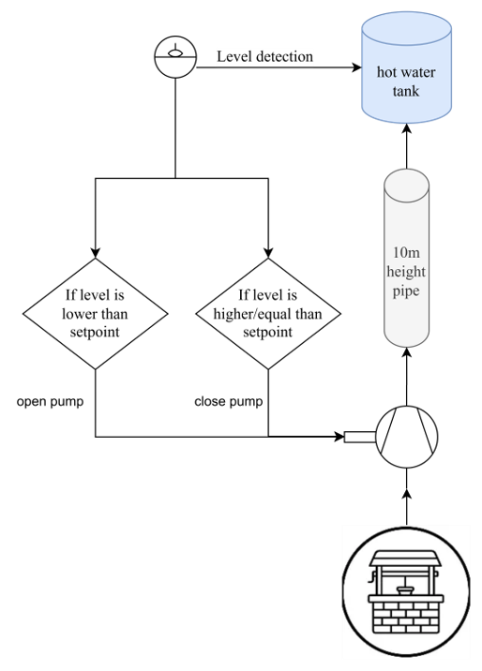
Fig. 1. System schematic of Mini Project 1

- Model Content

Table 1 Models contained in Mini Project 1

Name | Description
Boundary_PT | Boundary with prescribed pressure, temperature, composition and trace substances
ControlledPump | Centrifugal pump with ideally controlled mass flow rate
StaticPipe | Basic pipe flow model without storage of mass or energy
RealExpression | Set output signal to a time varying Real expression
Hysteresis | Transform Real to Boolean signal with Hysteresis
booleanToReal | Convert Boolean to Real signal
OpenTank | Simple tank with inlet/outlet ports
MassFlowSource_T | Ideal flow source that produces a prescribed mass flow with prescribed temperature, mass fraction and trace substances
System | System properties and default values
TimeTable | Generate a signal by linear interpolation in a table

Using These models, the pumping system of hot water tank can be created in dymola as diagram showed in figure 2.
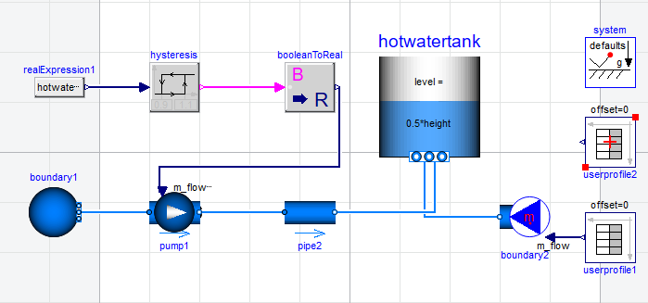
Fig. 2. System diagram of Mini Project 1 in dymola

- Assumptions
The assumption I made for Mini Project 1 contains:
- Fixed value of water pressure in the well is 1 bar, fixed value of temperature of it is 20 Celsius. The medium used in this system is Modelica.Media.Water.StandardWater
- The pump’s flow characteristics are shown in Figure 3.

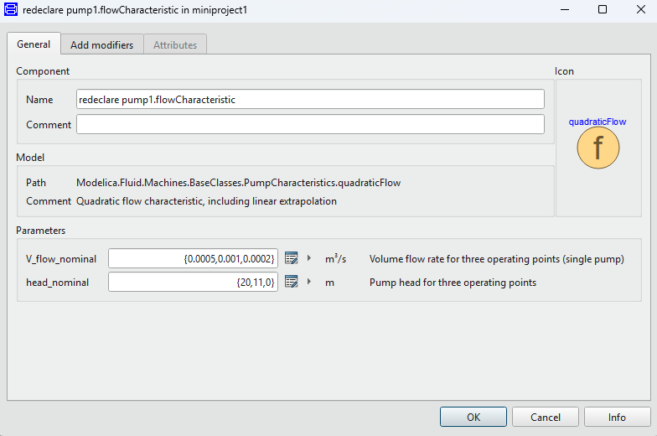
Fig. 3. Flow characteristic of pump

This set of parameters shows that when pump volume flow rate is 0.001 $m^{3}$/s, it should provide fluid the ability to overcome 11 m height of gravity. Considering the loss may apply for the water, this model set the head_nominal to 11 m, rather than 10 m.
- The pipe’s parameters are shown in Figure 4.
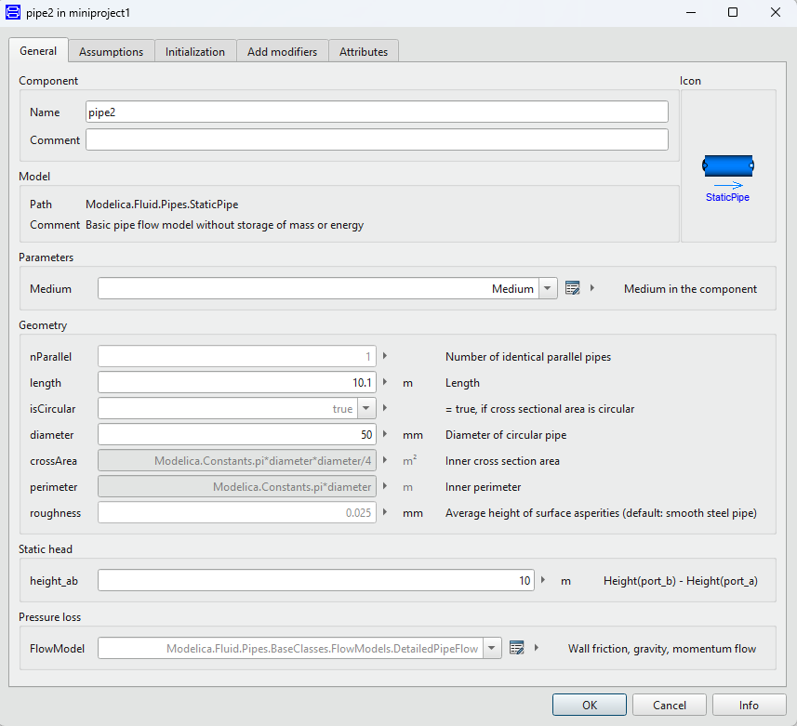
Fig. 4. Parameters of pipe

As shown in Figure 4, consider the low-mass flow this scenario maybe, this project takes 50 mm as diameter. The height here, as per request by assignment, is set to 10 m.
- The tank’s parameters are shown in Figure 5.
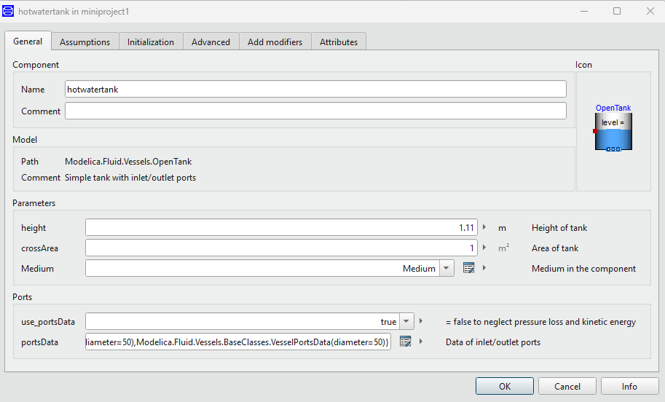
Fig. 5. Parameters of tank

In order to make this hot water tank to be more realistic, this project set the maximum volume of 1.1 $m^{3}$, so that water level can have some flexibility, and enough room for sudden cut of demand.
- This project assume that the pump will be pumping water at 0.5 kg/s rate when water volume in hot water tank below 0.9 $m^{3}$, and will stop pumping water when volume is greater than 1.1 $m^{3}$.this is realized by combination of hysteresis and booleanToReal model.
- Users’ Profile
Two users’ profiles are shown in Figure 6 and Figure 7.

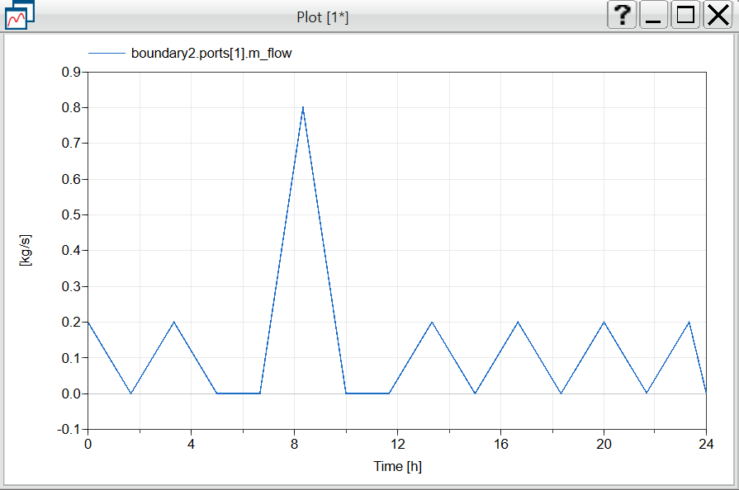
Fig. 6. Profile of user 1

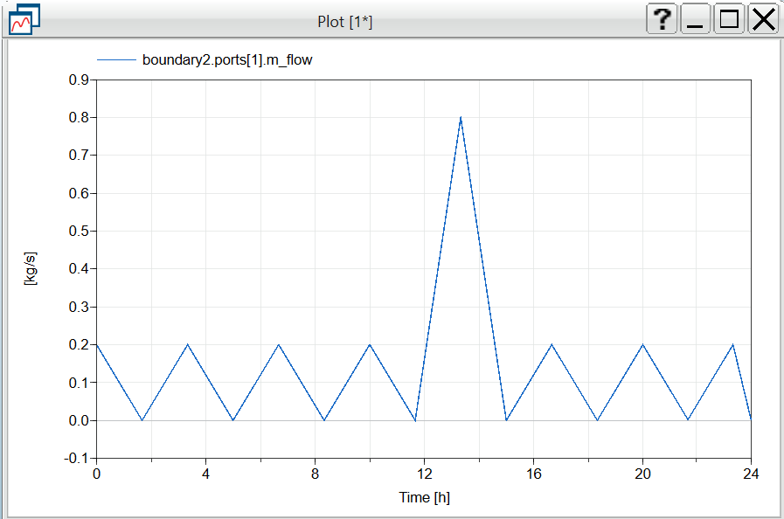
Fig. 7. Profile of user 2

These two user profile both cover a whole day (24 h). User 1’s peak load occurs in 8:20 AM in morning, this profile is for families may be having shower in morning, which takes up great deal of load. user 2’s peak load occurs in 13:20 PM at afternoon, this profile is for families may be having shower in the afternoon. These profile cover two kind of typical demand behavior of family using hot water.
- Simulations Results&Explanation
Based on the load curve shown in Figure 6 and Figure 7, This Project had conducted two full-day simulations of the system.
This project have found that:
As shown in Figure 8 and Figure 9, the overall water level in hot water tank can stay relatively stable to full and react to load fluctuations well. In Figure 8 and Figure 9, the green line and red line shows the low limit and high limit of hysteresis, the purple line shows the demand load, blue line shows water level inside the tank.
From these graphs we can understand when facing load changes large at 80 %, in both case water level can be low as 0.4$m^{3}$. That’s because my settings for pump mass flow rate still are not enough to maintain such changes, but this problem can be solved after some alters in pump mass flow rate settings. But the system still bounce back quickly, so this system should be capable for the task demand by MiniProject 1.
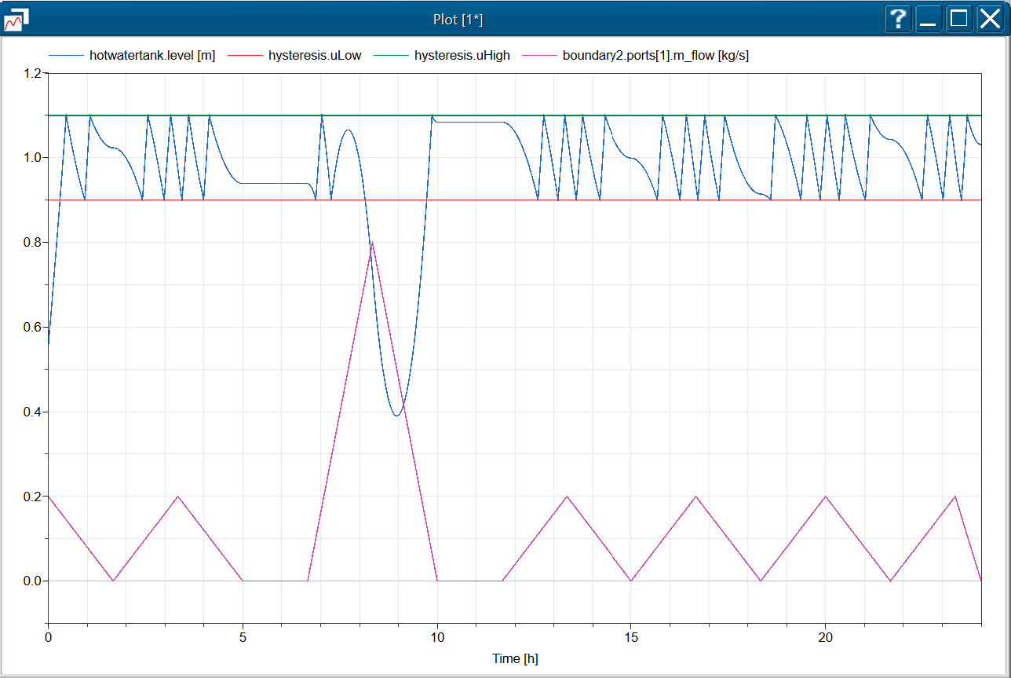
Fig. 8. Water level under load of user 1
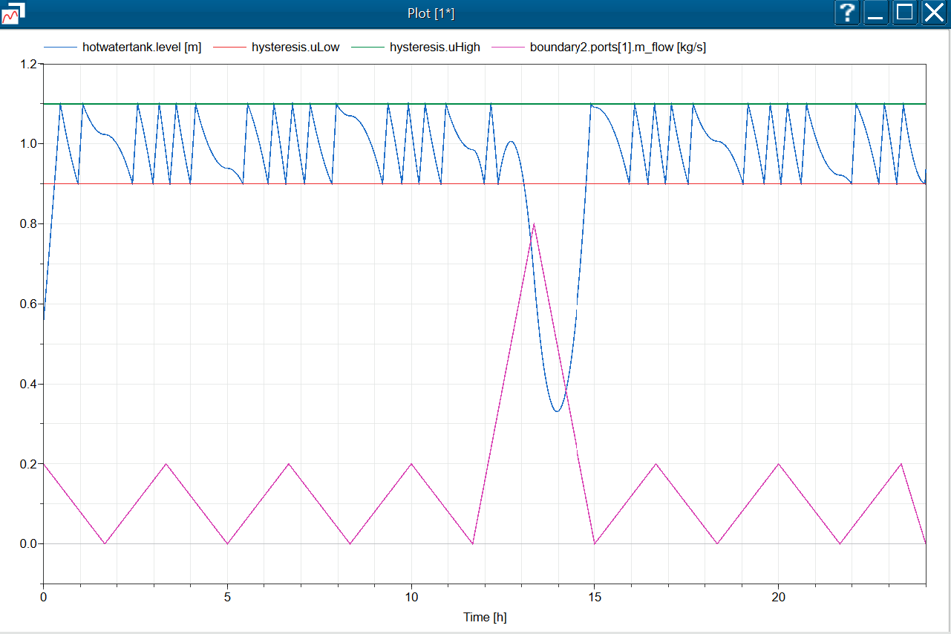
Fig. 9. Water level under load of user 2

